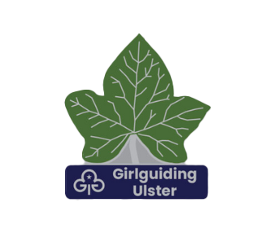

Girlguiding Ulster Ivy Award for Young Members

Awarded for: Outstanding service to Girlguiding

Who can receive it? Members of Girlguiding Ulster between the ages of 4-18 years

Proposed by: Any adult member of Girlguiding Ulster but the nomination must be
endorsed by the County Commissioner

Selection Procedure: Nominations to go to
Girlguiding Ulster Thanks & Recognition Group

Notes:

Please read the Frequently Asked Questions which will help with writing this nomination

There are no formal criteria laid down and each case is assessed on its own individual merits

The Thanks & Recognition Group will be looking for girls who exemplify the Guide Laws, appropriate to their section, in all aspects of their everyday life and have;

- Given exceptional service to their unit or a particular project at district, division, county or Ulster level
or
- Coped with exceptional circumstances in life
or
- Shown prompt action and courage in an emergency

It is important to note that when completing the nomination form, the emphasis should be placed on the contribution that the young person has made to guiding.

PLEASE REMEMBER:
The whole process must be carried out in confidence and the person being nominated must not be told

Girlguiding Ulster Ivy Award for Young Members

Nominee Details
Name:

Date of Birth:

Unit Name:
County:
Proposer Details
Name:
Tel Number:
Email address:
Current Appointment:
Membership Number:

Reasons for Nomination
Please complete one or more of the boxes below and remember to refer to the notes and FAQs.

- How has this person given exceptional service to their unit or a particular project at district, county or Ulster level ?

- How have they coped with exceptional circumstances in life?

- How have they shown prompt action and courage in an emergency? Please include any photographic, journalistic or any other evidence (e.g. a letter from a witness) if possible.

Endorsement by County Commissioner (this must be very honest and can be negative or positive)
Can you confirm that the GO record is up to date?
Are you happy that this nomination is presented to the Thanks & Recognition Committee?

Any comments – Please feel free to add in any additional information that you feel may not have been mentioned or expanded in detail by the proposer.

County Commissioner Name ...........................................................please print clearly)

County Commissioner Signature: .......................................................................

Please send to: Girlguiding Ulster Thanks & Recognition Group, Lorne, 30 Station Road, Craigavad, Holywood, Co Down BT18 0BP, marked ‘Confidential’

